

**كلية العلوم الحاسوبية والمعلوماتية**

**College of Computer and Information Sciences**

Hotel Booking Application

*Students:*

|  |  |  |
| --- | --- | --- |
| **Yazan Mohammad Amin** | **202010454** | [**yznbrhm77@gmail.com**](mailto:yznbrhm77@gmail.com) |
| **Basel A’yesh** | 202110128 | [baselayesh46@gmail.com](mailto:baselayesh46@gmail.com) |

*Supervisor:*

**Dr. Alaa Abu Dhawabah**

*A project report submitted in partial fulfillment of the requirements   
for B.Sc. degree in Software Engineering.*

*Amman - Jordan*

*2024/202**5*

**Table of contents**

|  |  |
| --- | --- |
| Table of Content | 2 |
| List of Figures | 3 |
| Chapter Two: System Analysis | 4 |
| 2.1 System Analysis | 4 |
| 2.1.1 Functional Requirements | 5 |
| 2.1.2 Non-Functional Requirements | 6 |
| 2.1.3 Use Case Diagram | 7 |
| 2.1.4 Class Diagram | 8 |
| 2.1.5 Sequence Diagram | 9 |
| 2.1.6 Activity Diagram | 11 |
| 2.1.7 Data Flow Diagram (DFD) | 12 |

List of Figures

|  |  |  |
| --- | --- | --- |
| Figure 1 | Use a Case Diagram | 7 |
| Figure 2 | Class Diagram | 8 |
| Figure 3 | User Register Sequence Diagram | 9 |
| Figure 4 | User Login Sequence Diagram | 9 |
| Figure 5 | User Reserve a Room Sequence Diagram | 10 |
| Figure 6 | Activity Diagram | 11 |
| Figure 7 | DFD | 12 |

Chapter Two: System Analysis

2.1 System Analysis

the process of identifying and documenting system requirements and analyzing them to ensure that user requirements are understood and to ensure that the system properly meets these requirements. *Here are some important points in system analysis:*

1. Determine requirements: We must define all the requirements related to the hotel booking application, including the basic functions that the application must perform and additional requirements such as security and performance.

2. User Analysis: We need to understand the app users and their needs, including customers who search for hotels, employees who manage reservations, and hotel managers who need to manage data.

3. Analysis of current processes: We must examine the current processes of hotel booking, whether manual or online, to understand how these processes can be improved through the application

4. Data Analysis: We need to identify and analyze all the data that will be stored and used in the application, such as hotel data, booking, and users.

5. Security and privacy analysis: We must determine the security and privacy requirements of the application, including protecting user data and financial transactions and ensuring that there are no security vulnerabilities.

2.1.1 Functional Requirements

1. User Registration:

* Users must be able to create accounts with unique usernames and passwords.

2. Room Search:

* Users should be able to search for available rooms based on criteria such as dates, location, and room type.

3. Room Reservation:

* Users should be able to select specific rooms, enter reservation details such as check-in/check-out dates, and confirm their booking.

4. Payment Processing:

* The system must process booking payments securely using different payment methods such as credit / debit cards, and online payment platforms.

5. Manage Reservation:

* Hotel staff should have access to a dashboard where they can manage room availability, view current reservations, and update room availability in real-time.

6. Notifications:

* Users should receive confirmation emails or messages upon successful booking, as well as reminders or notifications about upcoming bookings.

7. Cancellation:

* Users should be able to cancel their bookings within a specified time frame and receive refunds by the cancellation policy.

2.1.2 Non-Functional Requirements:

1. Security:

* The system must implement strong encryption protocols to protect user data and payment information.

2. Performance:

* The application should be responsive and able to handle many concurrent users without any slowdowns or major errors.

3. Scalability:

* The system must be scalable to accommodate the increasing number of users and increased demand for booking.

4. User Experience:

* The user interface should be intuitive, easy to navigate, and visually attractive to enhance the user experience.

5. Reliability:

* The system must be reliable, with minimal downtime for maintenance and updates, to ensure continuous availability to users.

6. Compatibility:

* The app should be compatible with a variety of devices such as computers and smartphones.

7. Accessibility:

* The system must comply with accessibility standards to ensure that users with disabilities can access and use the application effectively.

2.1.3 Use Case Diagram

Hotel Booking App

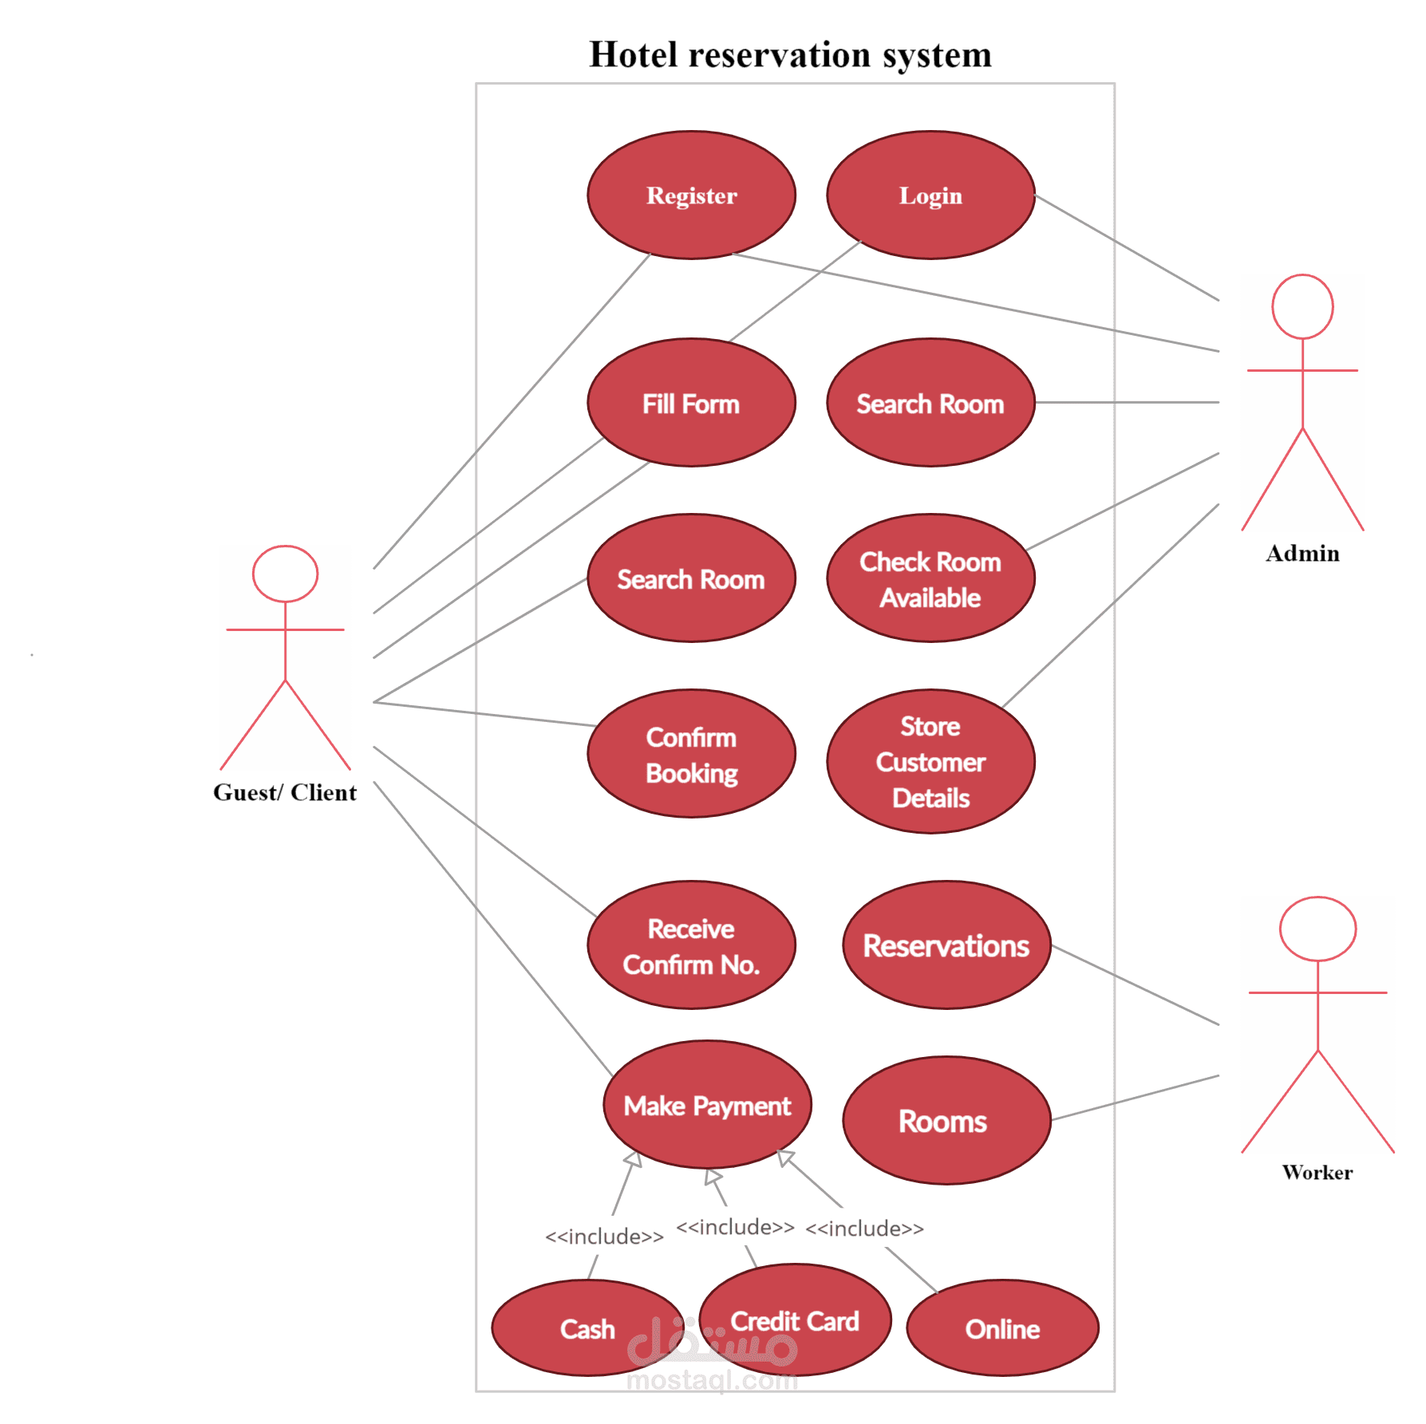

Figure (1): Use a Case diagram of a system

2.1.4 Class Diagram

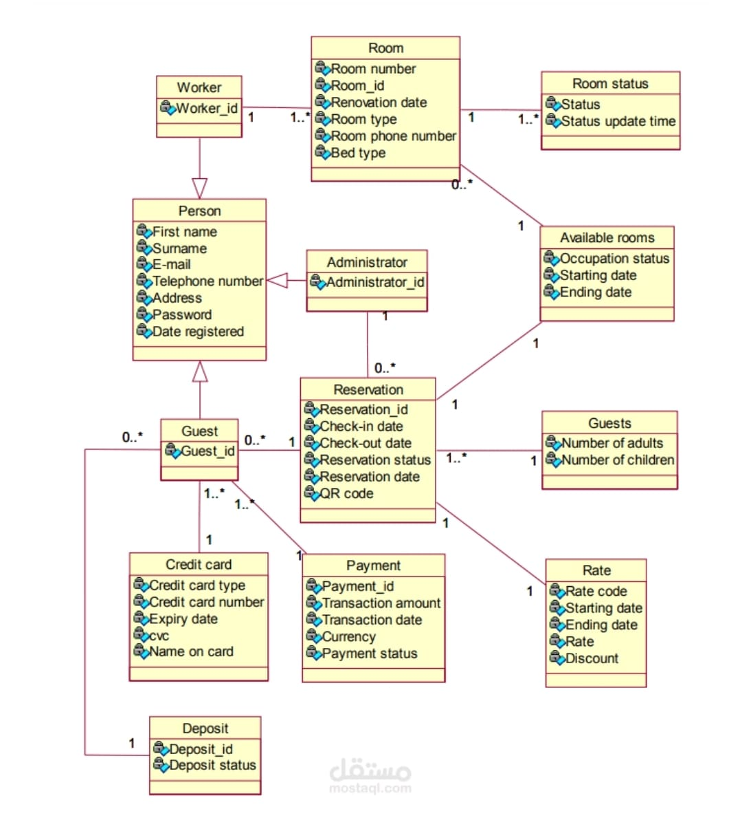

Figure (2): Class Diagram

2.1.5 Sequence Diagram

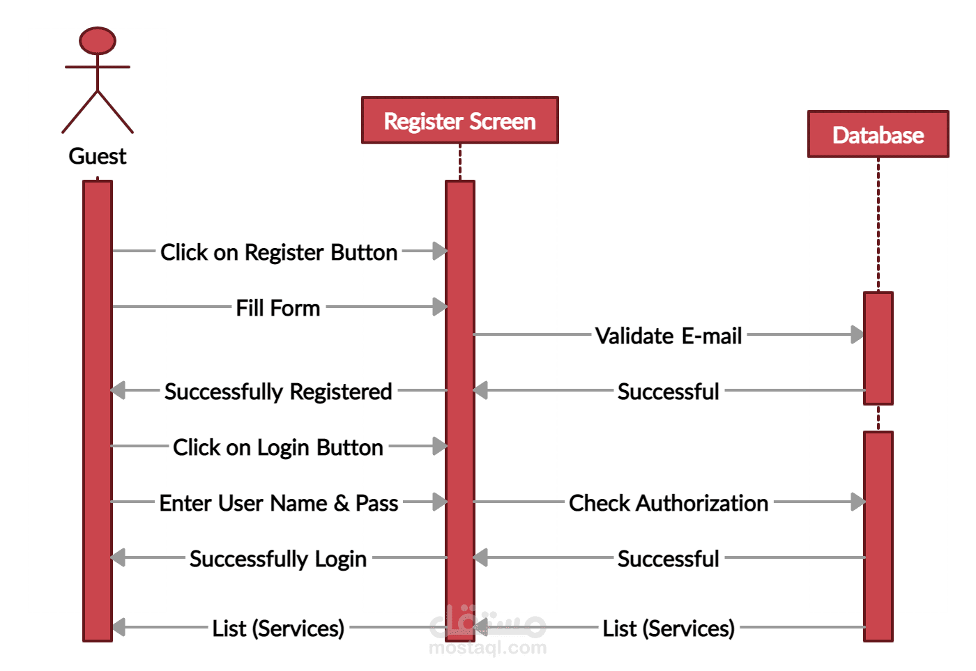

**Figure (3): User Register Sequence Diagram**

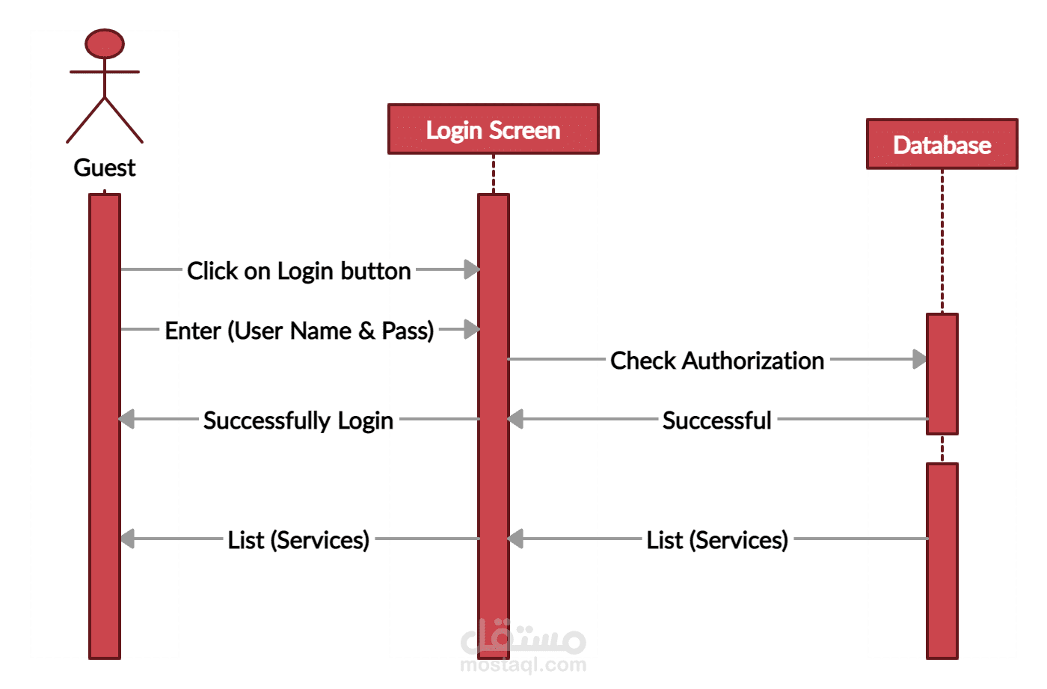

**Figure (4): User Login Sequence Diagram**

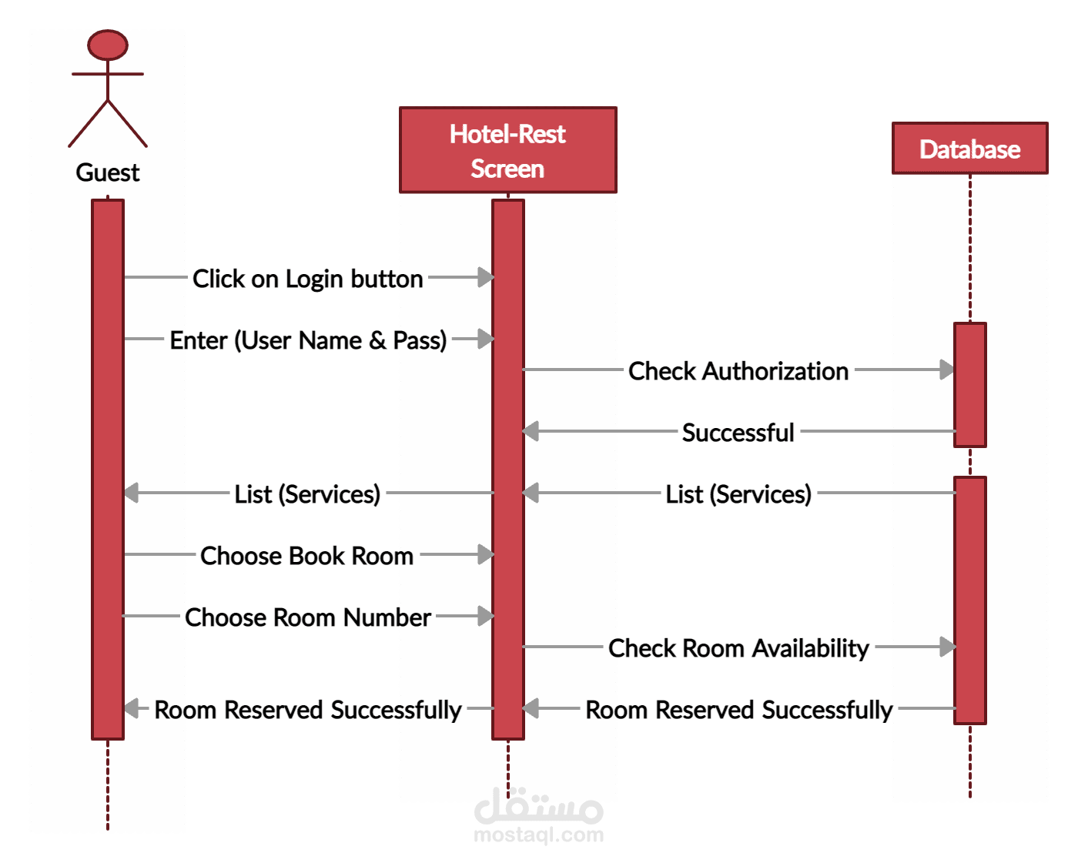

**Figure (5): User Reserve a Room Sequence Diagram**

**2.1.5 Activity Diagram**

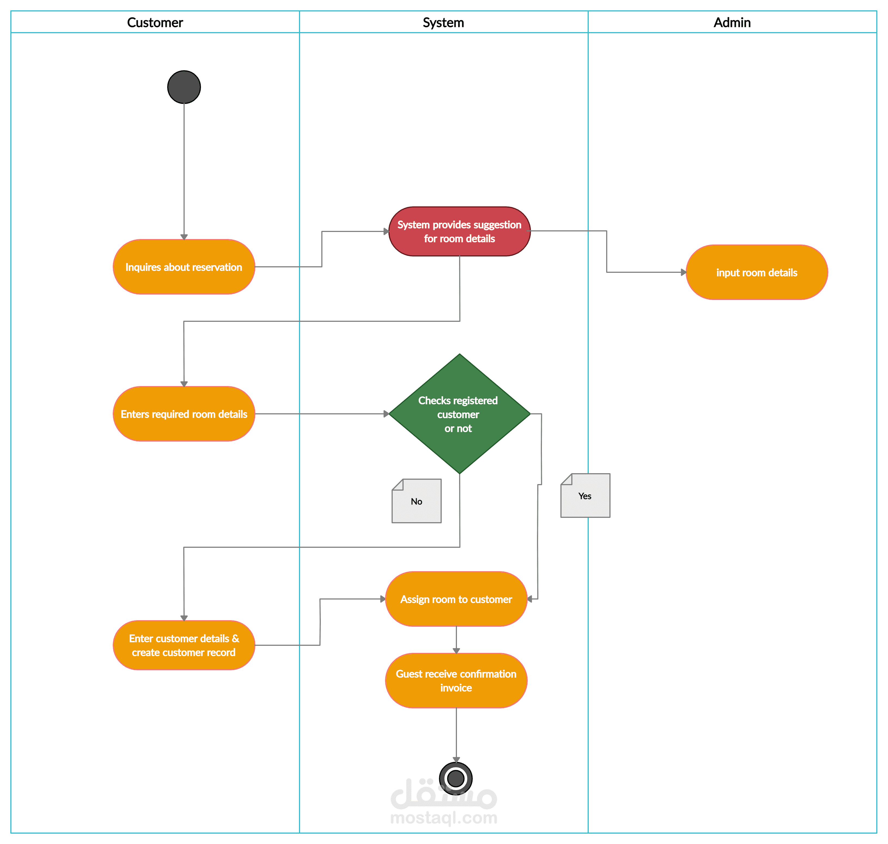

**Figure (6): Activity Diagram**

2.1.6 Data Flow Diagram (DFD)

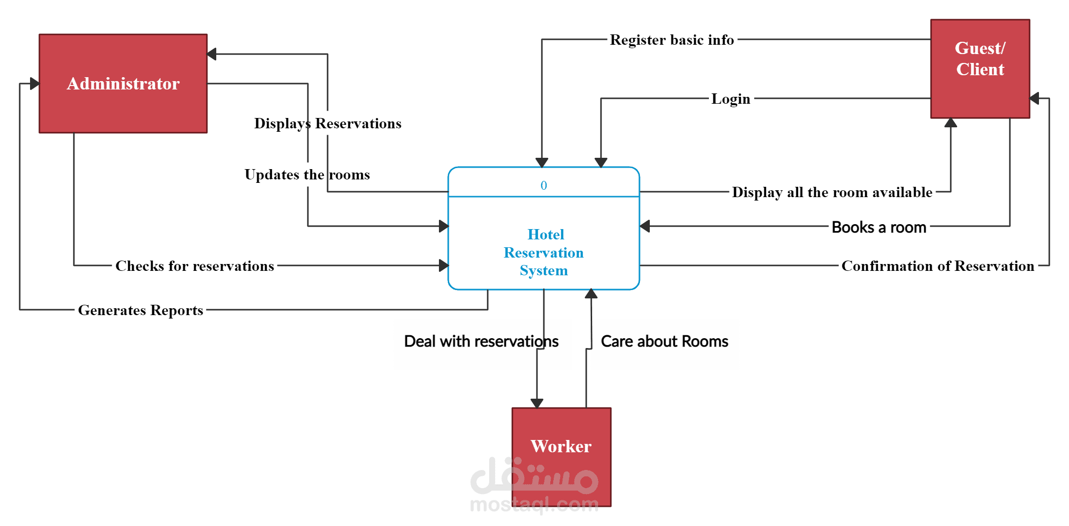

Hotel Booking App

**Figure (7): DFD**

